**Group No: 01**

**Course No**: CSE 308

**Course Name**: Software Design and Information System Design Sessional.

**Automation of BCB’s Game Development Committee**

**Group Members:**

1005091

1005111

1005113

1005115

1005120

**Introduction:**

Bangladesh cricket is one of the greatest prides for Bangladesh. Though Bangladesh cricket has advanced significantly in international level, unfortunately the domestic cricket management and maintenance has not been well-organized yet. Therefore, in spite of having lots of cricket loving talented players all over the country they are not inspired and utilized properly for sake of the Bangladesh cricket due to lack of seriousness and faulty system in the domestic cricket infrastructure. It is our belief that if we can improve this system to improve the domestic cricket infrastructure then no talent will be waste and our cricket will improve significantly.

**Subsystems:**

Our subsystems are:

* Program Management System
* Divisional Cricket Management System
* Academy Operations Management System
* Coach Management System
* Control Management System

**Data Flow Diagram:**

**Program Management System:**

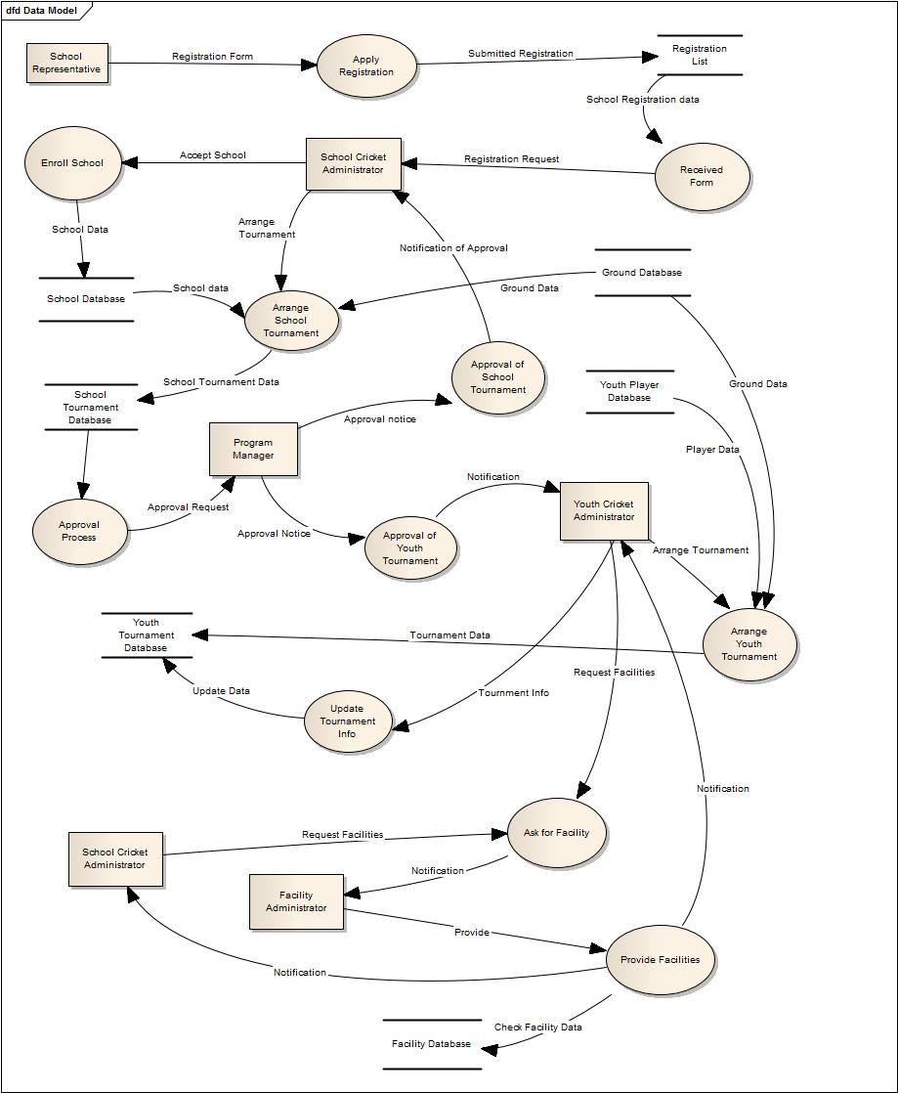

Course of events:

School representative applies for the registration and the data is stored in the registration list database. The registration request is sent to school cricket administrator. Then he will accept school registration and the data is stored in the school database. For arranging the school cricket tournament school database and ground database is flowed. Tournament data is saved. The data is sent for approval to program manager and he approves and the notification is sent.

For arranging the youth cricket tournament players database and ground database is flowed. Tournament data is saved. The data is sent for approval to program manager and he approves and the notification is sent.

Youth cricket administrator updates the tournament information and the info is saved in the youth tournament database.

**Divisional Cricket Management System:**

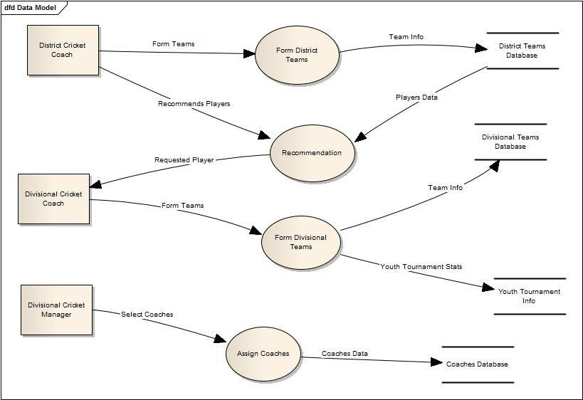

Course of events:

District cricket coach form district team and the data is saved in the database. He recommends some players data and the data is sent to divisional cricket coach. Then divisional cricket coach form divisional teams and save in youth tournament info. Divisional cricket manager assign coaches and saves it in coaches database.

**Academy Operations Management System:**

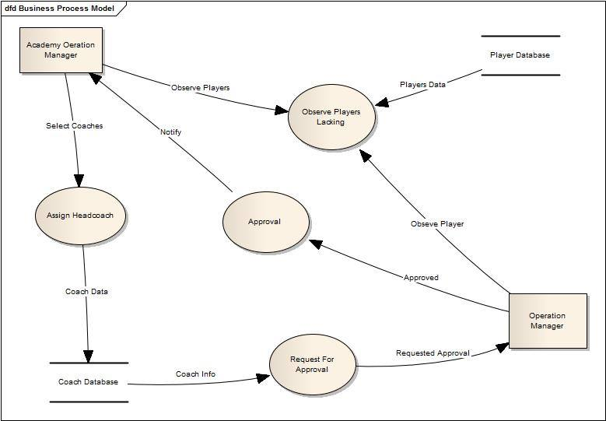

Players’ database sends players data and academy and operations manager observes it. Academy operations manager assign head coach and saves in coach database. Coach info is send for approval to operations manager. He approves and sends notification to operations manager.

**Coach Management System:**

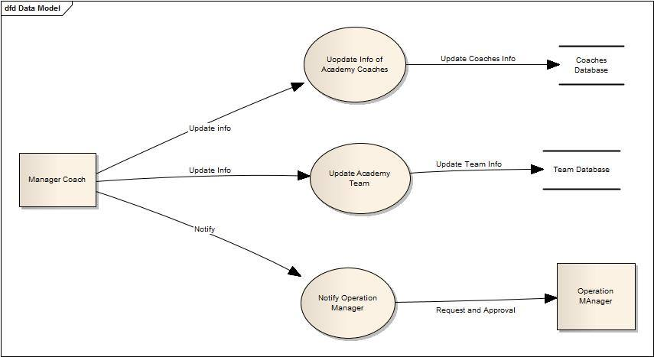

Course of events:

Manager coach updates info of academy coaches and saves in coaches database. he updates info of academy teams and saves in teams database. Manager coach notifies operations manager and sends request of approval to operation manager.

**Control Management System:**

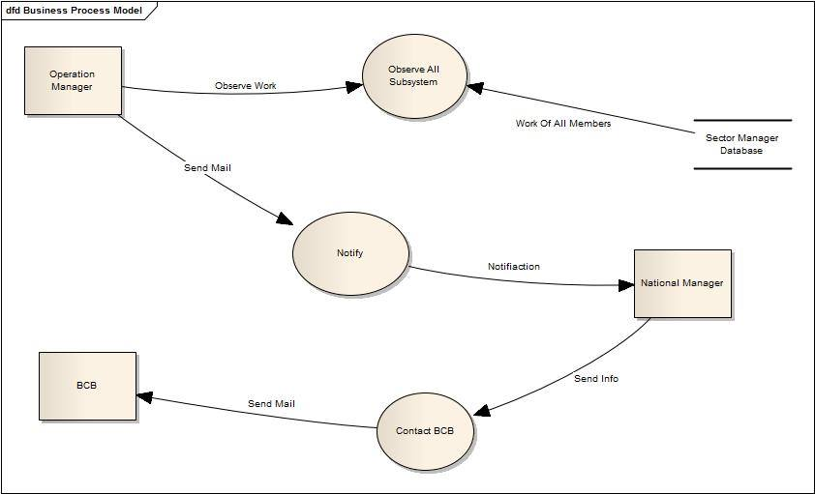

Course of events:

sector manager database sends info of work of members. Operations manager observes and sends mail and notify National manager. National manager sends necessary info to BCB by contacting BCB.

**Fish Bone Diagram**

**Program Management System:**

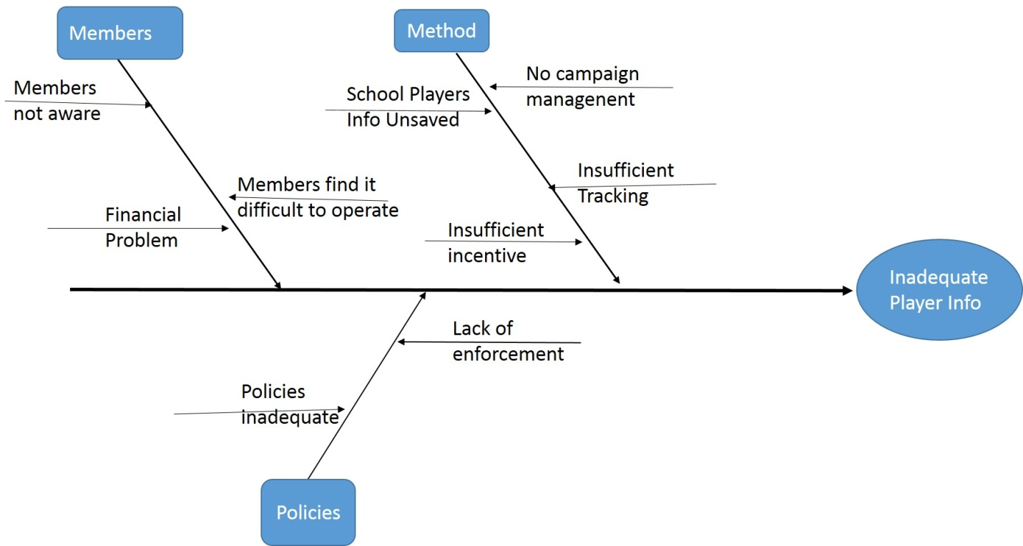

Our system basically works on keeping player info of root levels. In spite of that system fails to do so as it does not maintain any database of school team players. Member users’ negligence in co-operation, system’s inadequate policy are the major causes behind this effect.

**Divisional Cricket Management System:**

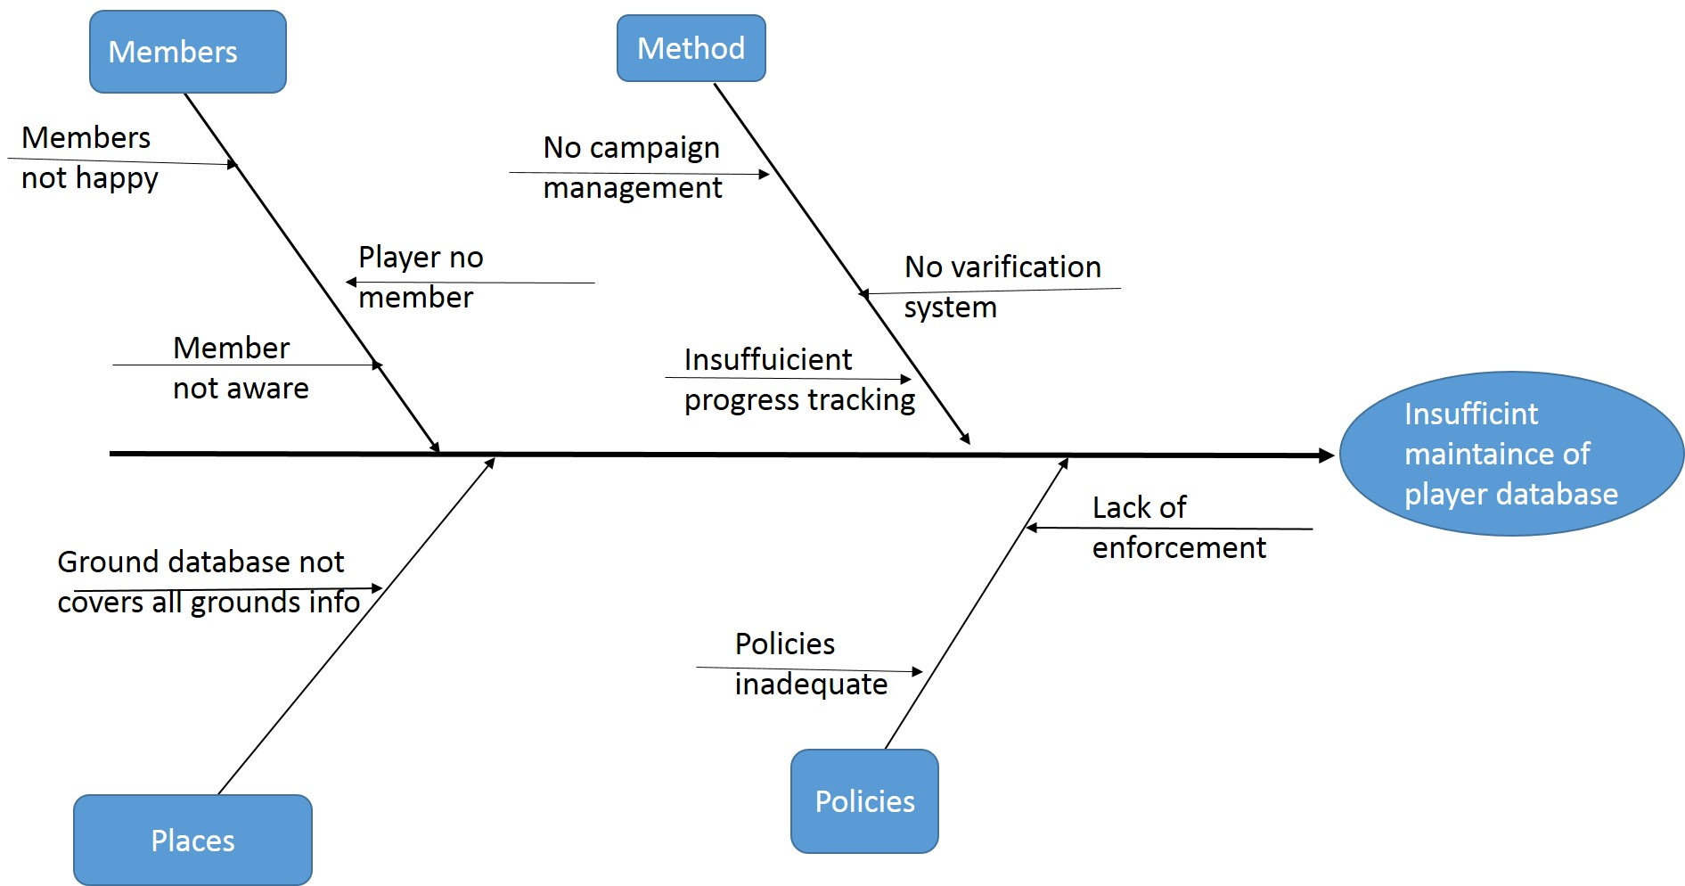

Inefficient and insufficient maintenance of district player database is again a problem here in the system. System does not conduct any campaign management notifying upcoming tournaments. Players being no user fail to be notified timely. No verification of players’ database, unawareness of members is other major causes.

**Academy Operations Management System:**

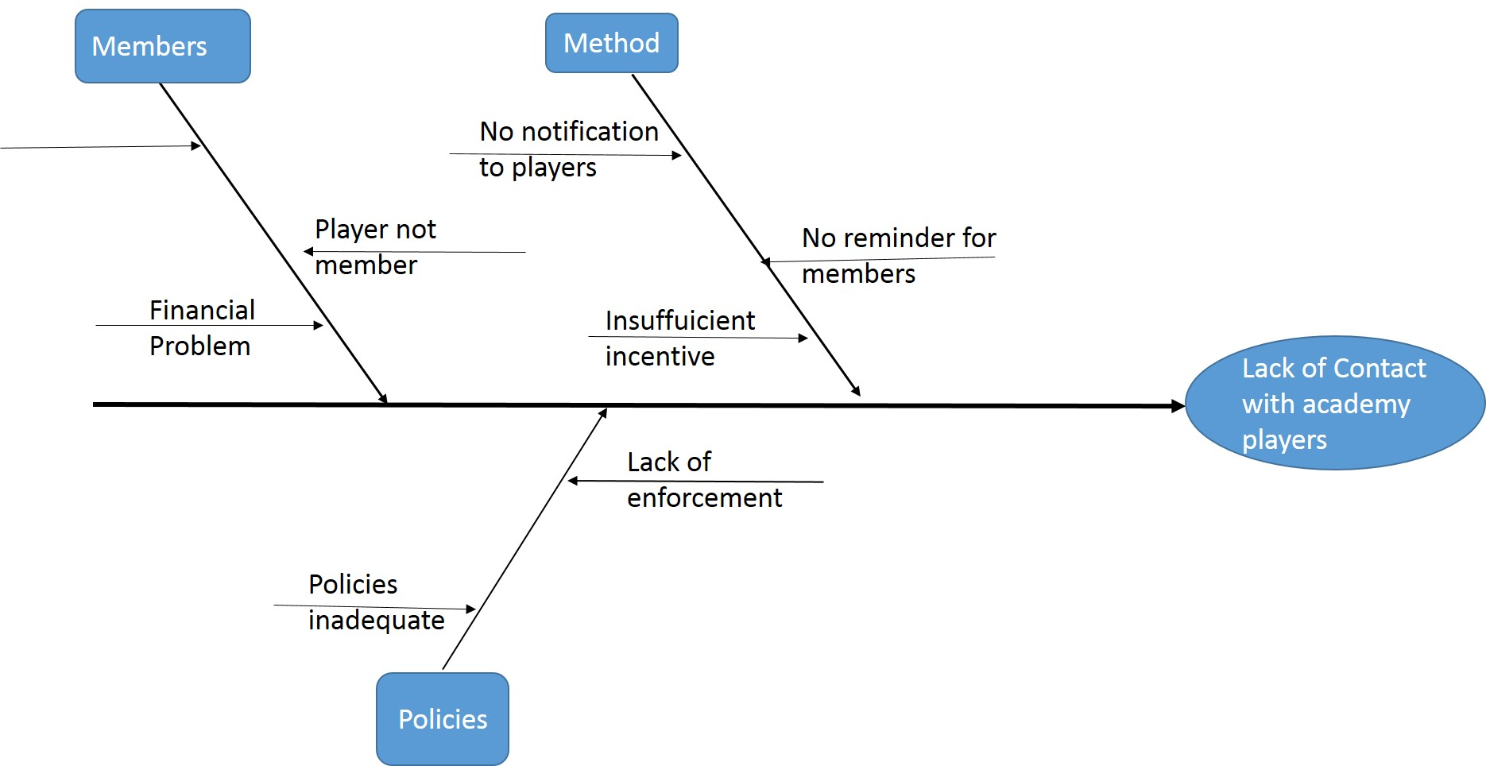

Our system maintains no management system for keeping contact between the academy players and academy manager. Players are not notified about their lacking and progresses properly. No reminders for members, financial problem of members are other causes.

**Coach Management System:**

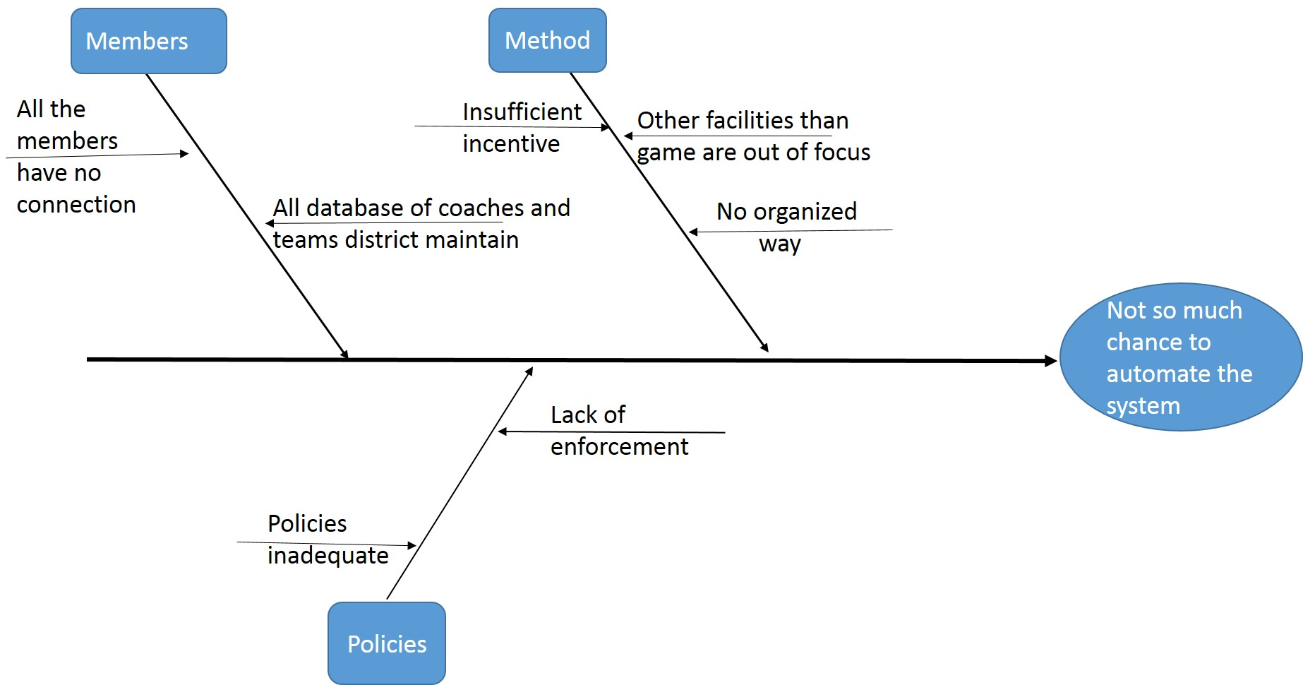

**Control Management System:**

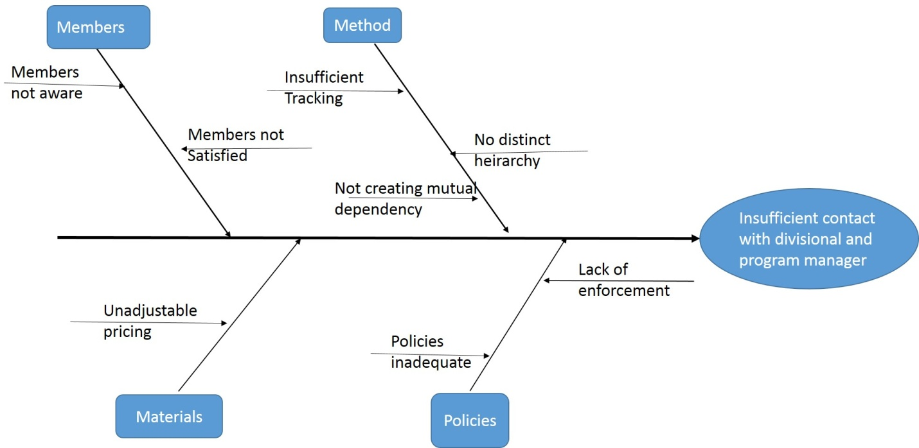

In control management system, system does not maintain any efficient contact between program manager and divisional cricket manager. No distinct hierarchy, lack of creating mutual dependency between them, member dissatisfaction is the major causes

**Operational Feasibility:**

* There was no organized system to maintain root level players’ database. In our system we maintained every players database.
* Improve communication between members.
* Player selection system is improved
* All Tournament Information is saved in database
* By maintaining the database in sti of facilities , members can easily know the amount of equipment in store.
* National level teams database is maintained, so that we can know the development of cricket in our country.

**Cultural Feasibility:**

* Players are benefited largely due to our player selection and management system
* Grounds will be kept under keen observation for proper maintenance so that they are always prepared for playing matches.
* All the coaches will find it easier to select and manage his team members .
* Committee members are facilitated in observing the work of the officials working under respective members

**Technical Feasibility:**

To implement this system, we used

* + .net
    - Available
    - Easier to implement
  + MySQL for database
  + PHP for Server side scripting.

Practical implications:

* Internet Connection is almost everywhere in Bangladesh
* System engineers and programmers will handle all kinds of problems in system.
* Operating a computer is not a hard work now a days.
* Everyone in the Game Development committee has the ability to operate the system.

**Cost Analysis:**

Cost can be categorized into two parts. The development cost and annual operating cost.

**Development Costs:**

|  |  |  |  |
| --- | --- | --- | --- |
| Sector | No of employee | Time period | Costs |
| System analysts (30,000tk/month) | 2 | 6 months | 360000tk |
| Programmer  (50,000tk/month) | 3 | 3 months | 450000tk |
| GUI designer  (20,000tk/month) | 1 | 2 months | 40000tk |
| Database Specialists  (30,000tk/month) | 2 | 3 months | 180000tk |

**Total Development Costs: 1030000 BDT.**

**Annual Operating Costs:**

|  |  |  |
| --- | --- | --- |
| Sector | No of employee | Costs |
| Programmer  (30,000tk/months) | 1 | 360000tk |
| System Librarian  (30,000tk/months) | 1 | 360000tk |
| Maintenance agreement to server  (2000 tk / year) | -- | 2000tk |
| Internet Connection  (2000tk/months) | -- | 24000tk |

**Total Annual Costs: 746000 BDT**

**Cost-benefit analysis:**

As we are implementing the project as if BCB is developing it, there is no monetary benefit associated with the project. So cost-benefit analysis part is discarded

**Tangible Benefits:**

* Decrease Response Time
* Reduce School registration steps
* Save Time
* Reduce paper works

**Intangible Benefits:**

* Improve player selection system
* Improve Tournament scheduling system
* Monitoring over players is easier
* Better communication between members of this committee
* Better monitoring others work
* Better decision making
* Better service to community